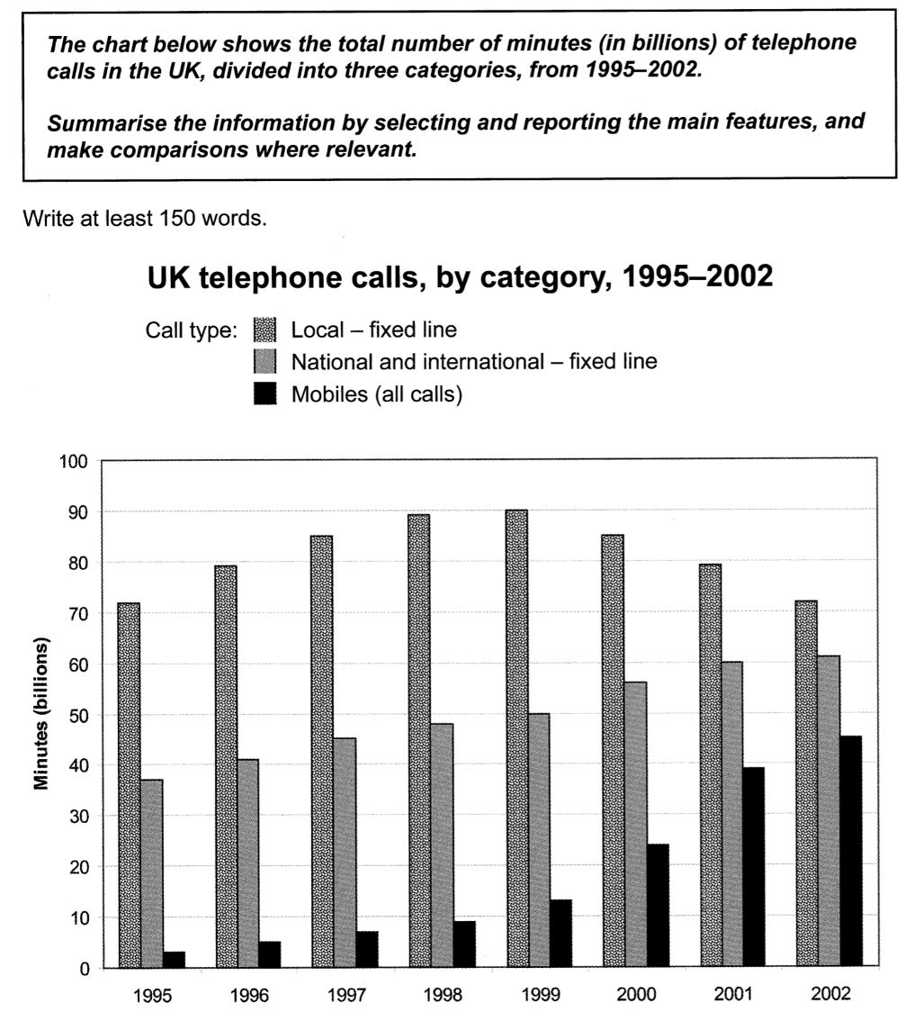
题目分析：
这个图是柱状图，动态图，时间是1995-2002

描述对象：the total number of minutes of telephone calls
单位: billion
时态：过去时

Overview：两个比较维度：大小：local fixed line一直最大。趋势：在后半段，local fixed line的优势减少，其他两种电话的流行度上升。

段落结构：local fixed line一段，剩下两种一段

Main features: 头尾数据，最大值。Mobiles的初始数据太小，可以忽略。

Comparisons：
趋势: local fixed line先升后降，national and international fixed line稳步上升， mobiles在1999年后急剧上升。
大小: local fixed line的初始值远远高于另外两种, 最终数值与初始值相同。national and international fixed line的最终数值接近 local fixed line。Mobiles的初始值非常小。

语言：动态对比，大小比较。

具体写法，可以参考下面的范文：

The bar graph gives information about three kinds of telephone calls in the UK between 1995 and 2002.

Overall, local fixed lines dominated the market. However, their advantage diminished in the second half of the period, as the popularity of national and international fixed lines and mobiles surged.

In 1995, the total number of minutes of calls made by local fixed lines was about 71 billion, far more than the statistics for the other two categories. From that point, this figure increased gradually and peaked at 90 billion in 1999. After that time, it experienced a stable downward trend, falling to the 1995 level in the end.

On the other hand, the usage of national and international fixed lines saw a steady upward trend, rising from roughly 38 billion in 1995 to just more than 60 billion in 2002, close to that of local fixed lines. The figure for mobiles was negligible initially, but witnessed a dramatical increase after 1999, growing to approximately 45 billion in 2002.

(~167 words)

